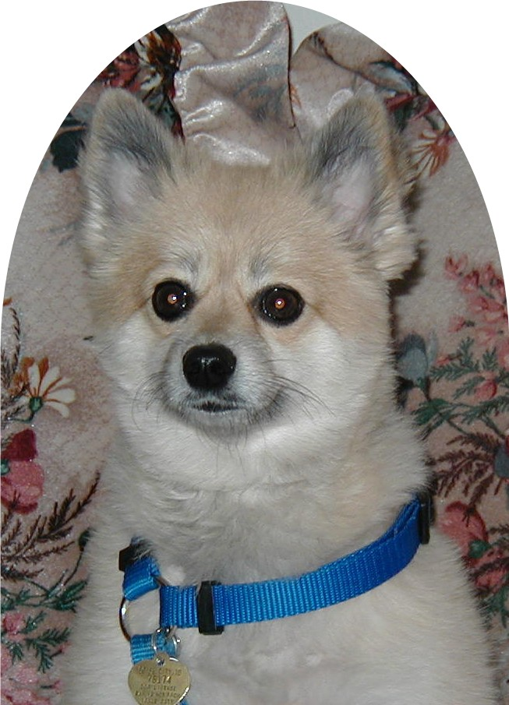

My name is Zachary. I am a proud graduate of Precision K-9. My owner was at her wit’s end with my behavior. I refused to stay at home alone and could bark all day long without losing my voice. My owner was desperate after animal control threatened her with taking me away because he thought I was too hot in my expensive kennel [a 1999 Honda Accord]. Of course, I was not too hot as I was probably the most spoiled, pampered pet within the continental United States. I went to live with Paula and was returned to my owner within 5 days. I am now kennel trained and can stay at home while my owner is at work. I can walk on my lease without pulling. I even go for hours without one bark. Life is swell. I am calm and self-assured and I owe it all to Paula McCollum. I would recommend her training skills to any and all who have a problem with their pet. So to all of you pets who have “issues” be sure to tell your owner because I know Paula can help you.

Zachary and Anita Campbell

